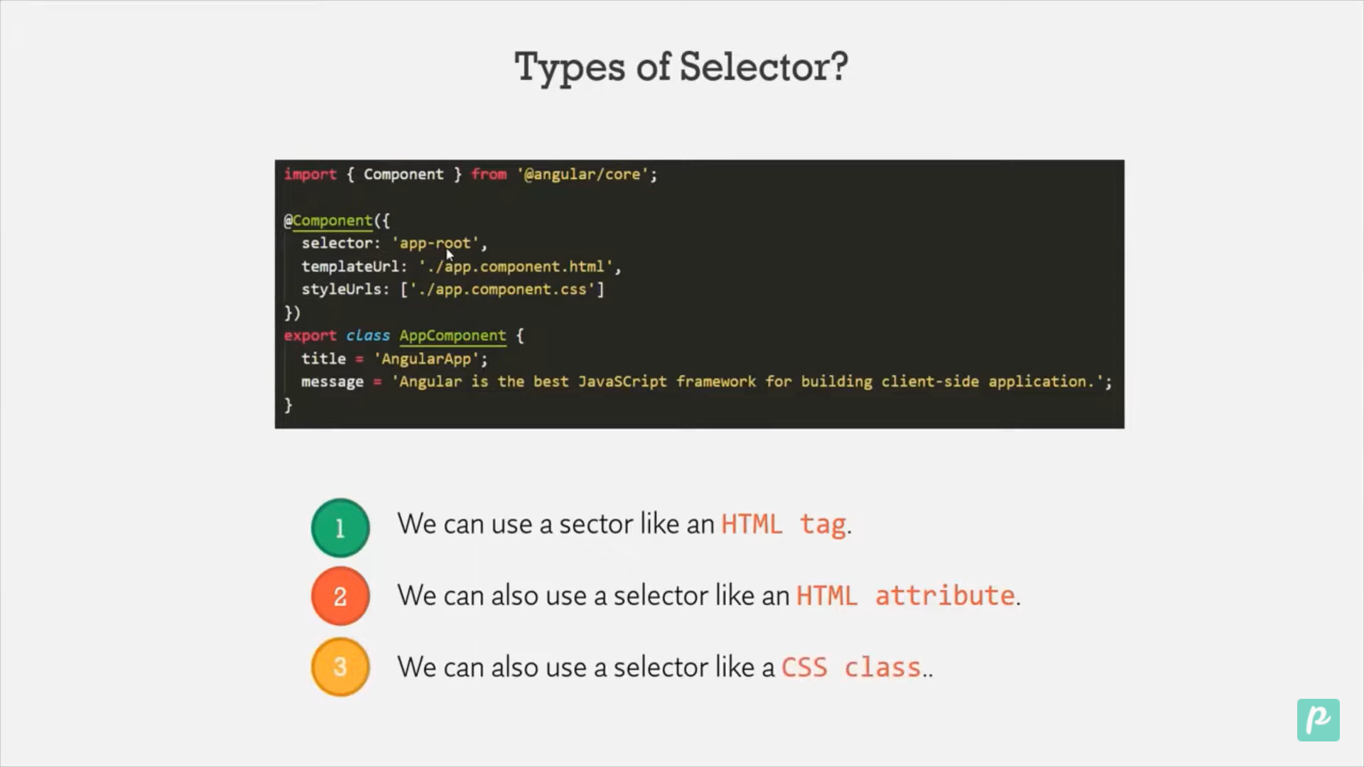

Now we will see how to use it as an HTML attribute

When we are writing it in [] bracket of selector we can use it as html attribute

@Component({

  selector: '[app-nav]',

  templateUrl: './nav.component.html',

  styleUrls: ['./nav.component.css']

})

export class NavComponent {

Now we can use it as an attribute .

<div app-nav></div>

Now to use Selector as a Css Class then use dot

@Component({

  selector: '.app-nav',

  templateUrl: './nav.component.html',

  styleUrls: ['./nav.component.css'],

})

export class NavComponent {}

<div class="app-nav"></div>

<!-- Below mentionis like css -->

<!-- <div class="app-nav"></div> -->

<!-- <app-nav></app-nav> this is like Html tag -->

<!-- Below mentioned is used as html attribute -->

<div app-nav></div>